**Name: Shangirne Kharbanda**

**Registration Number: 20BAI1154**

**IWP LAB-8**

**Form Validation using php and getting age**

**Code:**

**FileforExp8.php:**

This file is essentially a design and/or template of the form and it also is used to display errors using php and take input.

<!DOCTYPE html>

<html lang="en">

<head>

 <meta charset="UTF-8">

 <meta http-equiv="X-UA-Compatible" content="IE=edge">

 <meta name="viewport" content="width=device-width, initial-scale=1.0">

 <title>Registration form</title>

</head>

<body>

<?php

include "Exp8.php"

?>

<h2>Sign up Form</h2>

<br><br>

<form method="post" >

 name:

 <br><br>

 <input type="text" name="name">

 <span class="error"> <?php echo $nameErr; ?> </span>

 <br><br>

 E-mail:

 <br><br>

 <input type="text" name="email">

 <span class="error"> <?php echo $emailErr; ?> </span>

 <br><br>

 DOB:

 <br><br>

 <input type="date" name="DOB">

 <span class="error"> <?php echo $DOBErr; ?> </span>

 <br><br>

 Phone no:

 <br><br>

 <input type="text" name="phno">

 <span class="error"> <?php echo $phnoErr; ?> </span>

 <br><br>

 Card no:

 <br><br>

 <input type="text" name="Cardno">

 <span class="error"> <?php echo $cardnoErr; ?> </span>

 <br><br>

 Address:

 <br><br>

 <input type="text" name="Address">

 <span class="error"> <?php echo $AddressErr; ?> </span>

 <br><br>

 <br><br>

 <input type="checkbox" name="Agree">

 <span class="error"> <?php echo $AgreeErr; ?> </span>

 I agree

 <br><br>

 <button type="submit" formaction="<?php echo htmlspecialchars($_SERVER["PHP_SELF"]); ?>">

 Validate

 </button>

 <br><br>

 <button type="submit" formaction="store.php">

 Store data

 </button>

 <br><br>

</form>

</body>

</html>

**Exp8.php:**

This file initializes all the variables and is the backbone of the form.

<?php

 $nameErr = $emailErr = $DOBErr = $phnoErr = $cardnoErr = $AddressErr = $AgreeErr = "";

 $name = $email = $DOB = $phno = $Cardno = $Address = $Agree = "";

if ($_SERVER["REQUEST_METHOD"] == "POST") {

 if (empty($_POST["name"])) {

 $nameErr = "Name is required";

 } else {

 $name = input_data($_POST["name"]);

 if (!preg_match("/^[a-zA-Z ]*$/",$name)) {

 $nameErr = "Only alphabets and white space are allowed";

 }

 }

 if (empty($_POST["email"])) {

 $emailErr = "Email is required";

 } else {

 $email = input_data($_POST["email"]);

 if (!filter_var($email, FILTER_VALIDATE_EMAIL)) {

 $emailErr = "Invalid email format";

 }

 }

 if (empty($_POST["DOB"])){

 $DOBErr = "DOB is required";

 }

 else{

 $DOB = input_data($_POST["DOB"]);

 }

 if (empty($_POST["phno"])){

 $phno = "Phone number is required";

 }

 else{

 $phno = input_data($_POST["phno"]);

 if (!preg_match ("/^[0-9]*$/", $phno) ) {

 $phno = "Only numeric value is allowed.";

 }

 if (strlen ($phno) != 10) {

 $phnoErr = "Mobile no must contain 10 digits.";

 }

 }

 if (empty($_POST["Cardno"])){

 $cardnoErr = "Phone number is required";

 }

 else{

 $Cardno = input_data($_POST["Cardno"]);

 if (!preg_match ("/^[0-9]*$/", $Cardno) ) {

 $cardnoErr = "Only numeric value is allowed.";

 }

 if (strlen ($Cardno) != 16) {

 $cardnoErr = "Card no must contain 16 digits.";

 }

 }

 if (!isset($_POST['agree'])){

 $agreeErr = "Accept terms of services before submit.";

 } else {

 $agree = input_data($_POST["agree"]);

}

}

 function input_data($data) {

 $data = trim($data);

 $data = stripslashes($data);

 $data = htmlspecialchars($data);

 return $data;

 }

?>

**store.php:**

This file stores the data in the database.

<?php

    $conn = mysqli_connect("localhost","root","","login");

    if($conn === false){

        die("ERROR".mysqli_connect_error());

    }

    $regno=$_REQUEST['email'];

    $name=$_REQUEST['name'];

    $DOB=$_REQUEST['DOB'];

    $email=$_REQUEST['email'];

    $phno= $_REQUEST['phno'];

    $Cardno= $_REQUEST['Cardno'];

    $Address= $_REQUEST['Address'];

    $Agree=$_REQUEST['Agree'];

    $sql="INSERT INTO logininfo VALUES('$name','$email','$DOB','$phno', '$Cardno', '$Address', '$Agree')";

    if(mysqli_query($conn, $sql)){

        echo "data stored in a database successfully." ;

        echo nl2br("\n $name\n $email\n "

            . "$DOB\n $phno \n");

        echo nl2br("$Cardno\n $Address");

    } else{

        echo "ERROR: $sql. "

            . mysqli_error($conn);

    }

    mysqli_close($conn);

    ?>

**Output:**

Inserting data in the form and in turn, inserting it into the database created:

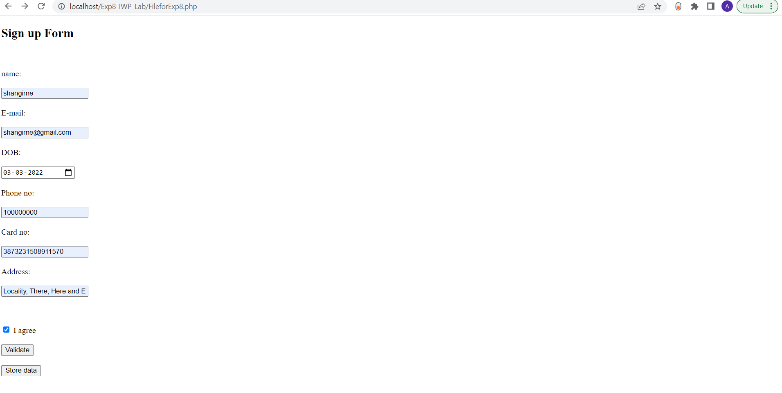

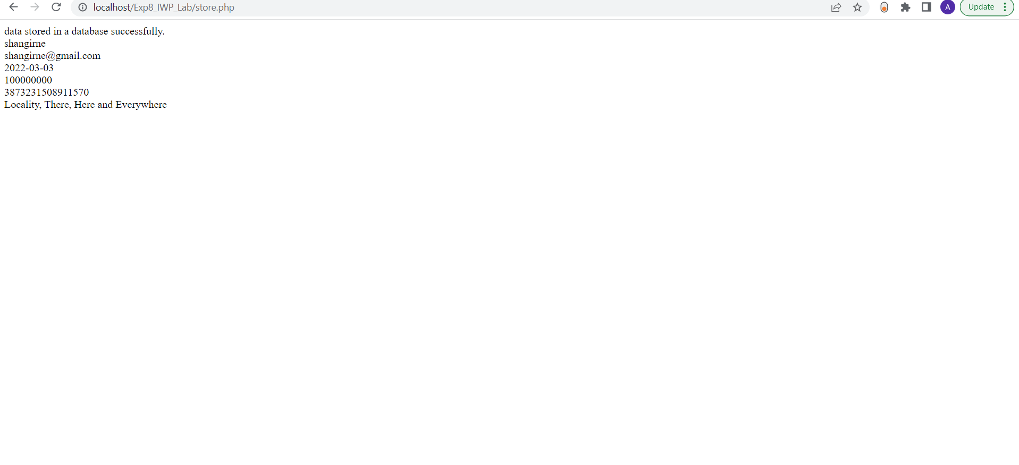

Creating the database and making the table using Mysql:

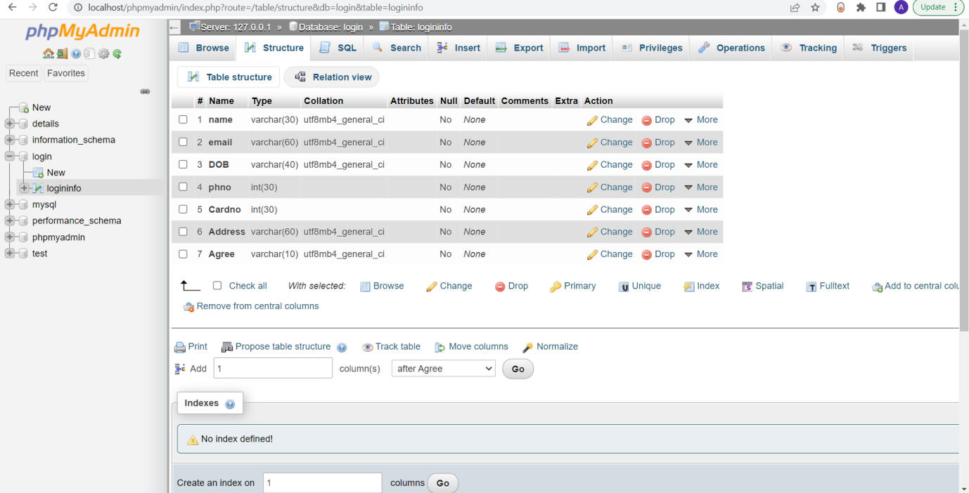

Validation using incorrect data:

